Bangalore Restaurant Zomato Data Analysis

1. Title Page
Zomato Bangalore Restaurant Analysis & Insights
Pratikshya Panda
B.Tech CSE (Data Science)
Date: [4th May 2026]

2. Abstract
This project analyses restaurant data from Bangalore to identify key factors influencing customer ratings, pricing strategies, and cuisine preferences. The dataset was cleaned and explored using Python-based data analysis tools. Through exploratory data analysis and visualization, patterns related to cost, location, and service features such as online ordering were identified. The study reveals that mid-range pricing, accessibility, and customer experience play a more significant role in determining restaurant success than premium pricing alone.

3. Introduction
The restaurant industry in Bangalore is one of the most competitive in India, with thousands of establishments competing for customer attention. In such an environment, understanding what drives customer satisfaction and high ratings becomes crucial.
This project uses real-world restaurant data to analyse customer behaviour and identify patterns that can help businesses improve performance. The goal is to move beyond simple data exploration and derive meaningful insights that can support data-driven decision-making in the food industry.

4. Dataset Description
The dataset used in this project contains detailed information about restaurants listed on Zomato in Bangalore.
Source: https://www.kaggle.com/datasets/bhanupratapbiswas/zomato

Key characteristics:
- Contains thousands of restaurant records
- Includes both numerical and categorical features
Important features:
- Restaurant Name
- Location
- Cuisines
- Cost for Two
- Ratings
- Votes
- Online Ordering Availability
- Table Booking Availability
- Customer Reviews
Challenges observed:
- Missing values in multiple columns
- Inconsistent rating formats
- Text-based noise in categorical features
- Duplicate entries

5. Data Preprocessing
Data preprocessing was a critical step to ensure the quality and reliability of analysis.
The following steps were performed:
- Removed duplicate records to avoid bias
- Handled missing values appropriately
- Converted ratings into numerical format
- Cleaned and standardized the “Cost for Two” column
- Processed categorical features such as location and cuisines
- Removed irrelevant columns
- Ensured consistent formatting across the dataset
These steps improved data consistency and made it suitable for analysis.

6. Exploratory Data Analysis (EDA)
6.1 Rating Distribution
The majority of restaurants fall within the rating range of 3.5 to 4.2, indicating moderate to good customer satisfaction. Very few restaurants exceed ratings above 4.5, suggesting strong competition at the top tier.
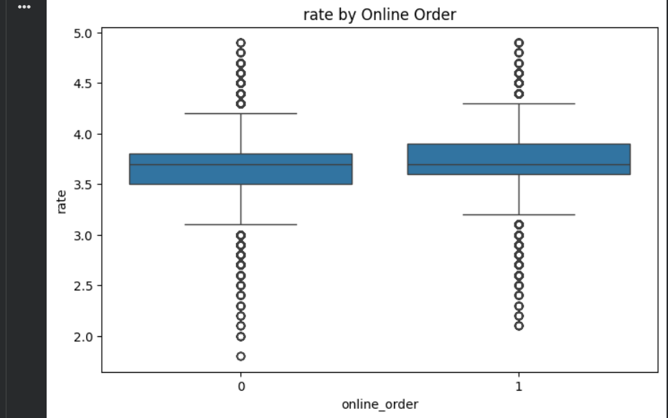

6.2 Cuisine Analysis
Certain cuisines dominate the market, particularly:
- North Indian
- Chinese
- South Indian
This indicates high customer demand but also potential market saturation in these categories.
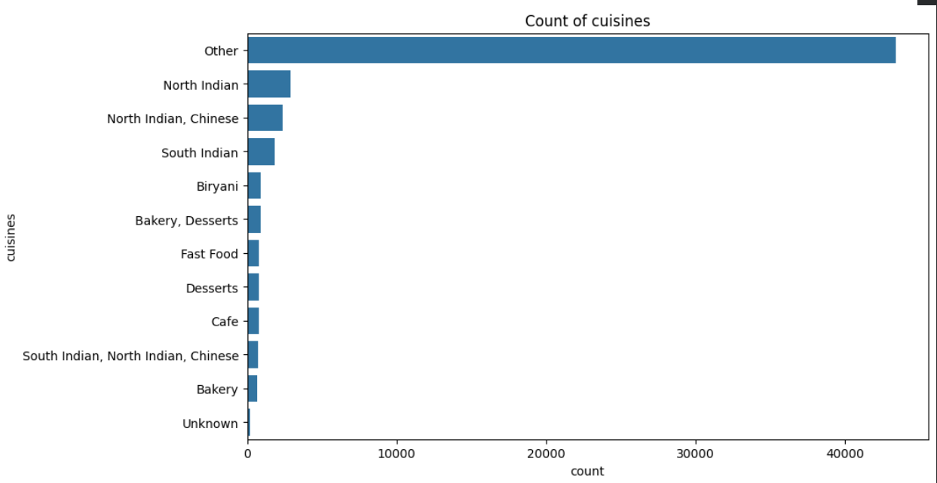

6.3 Price vs Rating Analysis
The analysis shows that restaurants in the mid-range pricing category (₹300–₹700) tend to achieve higher average ratings compared to expensive restaurants.
This suggests that customers prioritize value for money rather than premium pricing.
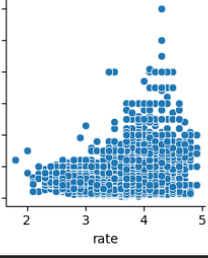

6.4 Location-Based Analysis
Restaurants located in high-density urban areas receive:
- More customer engagement
- Higher number of votes
- Better visibility
This highlights the importance of location in business success.
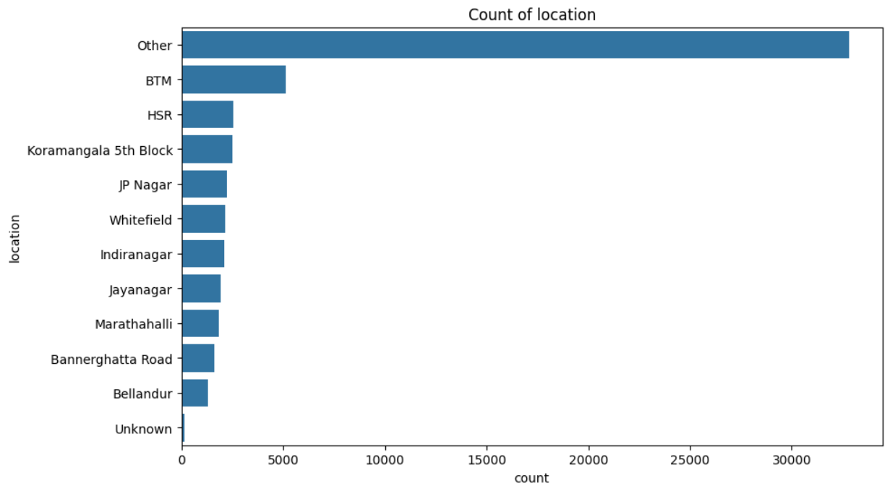

6.5 Online Ordering Impact
Restaurants offering online ordering services show:
- Higher interaction levels
- Better accessibility
- Increased customer reach
This indicates that digital presence plays a significant role in modern restaurant success.
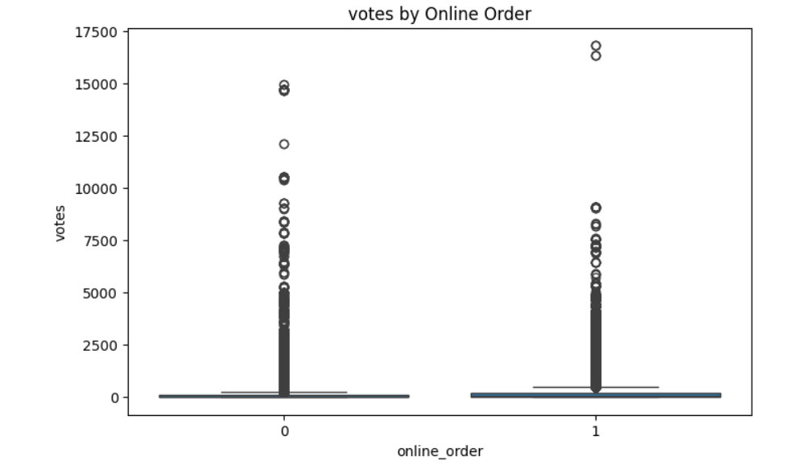

6.6 Customer Review Analysis
Word cloud analysis of customer reviews highlights commonly used positive terms such as:
- “good”
- “taste”
- “service”
This suggests that food quality and service experience are major contributors to customer satisfaction.
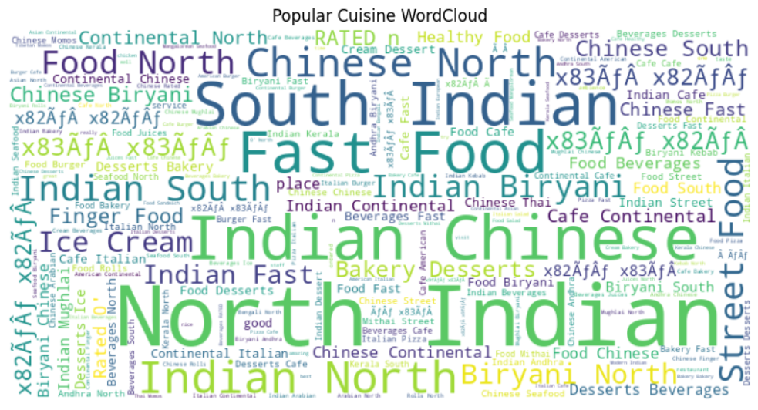

7. Key Findings
- Mid-range restaurants consistently outperform premium restaurants in terms of ratings
- Location significantly impacts restaurant visibility and success
- Online ordering increases customer engagement
- Popular cuisines dominate the market but face high competition
- Higher pricing does not guarantee better customer ratings

8. Business Recommendations
Based on the analysis, the following recommendations are proposed:
- Focus on mid-range pricing strategies to maximize customer appeal
- Enable online ordering systems to improve reach and convenience
- Select locations with high customer traffic and visibility
- Maintain strong food quality and service standards
- Offer popular cuisines with differentiation to stand out in a competitive market

9. Conclusion
This project demonstrates how data analysis can be used to uncover meaningful patterns in the restaurant industry. The findings indicate that success is driven more by accessibility, pricing strategy, and customer experience than by premium positioning.
The study highlights the importance of data-driven decision-making for improving restaurant performance in a competitive market.

10. Future Scope
- Develop a restaurant rating prediction model using machine learning
- Perform sentiment analysis on customer reviews
- Build a restaurant recommendation system
- Create an interactive dashboard using Streamlit or Power BI

11. Learning Outcomes
Through this project, the following skills were developed:
- Data Cleaning and Preprocessing
- Exploratory Data Analysis (EDA)
- Data Visualization
- Insight Extraction
- Business Understanding from Data

